**INTRODUCTION**

# What Is A Social Network?

Wikipedia defines a social network service as a service which “focuses on the building and verifying of online social networks for communities of people who share interests and activities, or who are interested in exploring the interests and activities of others, and which necessitates the use of software.”

A report published by OCLC provides the following definition of social networking sites: “Web sites primarily designed to facilitate interaction between users who share interests, attitudes and activities, such as Facebook, Mixi and MySpace.”

# What Can Social Networks Be Used For?

Social networks can provide a range of benefits to members of an organisation:

**Support for learning**: Social networks can enhance informal learning and support social connections within groups of learners and with those involved in the support of learning.

**Support for members of an organisation**: Social networks can potentially be used my all members of an organisation, and not just those involved in working with students. Social networks can help the development of communities of practice.

**Engaging with others**: Passive use of social networks can provide valuable business intelligence and feedback on institutional services (although this may give rise to ethical concerns).

**Ease of access to information and applications**: The ease of use of many social networking services can provide benefits to users by simplifying access to other tools and applications. The Facebook Platform provides an example of how a social networking service can be used as an environment for other tools.

**Common interface**: A possible benefit of social networks may be the common interface which spans work / social boundaries. Since such services are often used in a personal capacity the interface and the way the service works may be familiar, thus minimising training and support needed to exploit the services in a professional context. This can, however, also be a barrier to those who wish to have strict boundaries between work and social activities.

# Examples of Social Networking Services

Examples of popular social networking services include:

**Facebook**: Facebook is a social networking Web site that allows people to communicate with their friends and exchange information. In May 2007 Facebook launched the Facebook Platform which provides a framework for developers to create applications that interact with core Facebook features

**MySpace**: MySpace is a social networking Web site offering an interactive, user-submitted network of friends, personal profiles, blogs and groups, commonly used for sharing photos, music and videos..

**Ning**: An online platform for creating social Web sites and social networks aimed at users who want to create networks around specific interests or have limited technical skills.

**Twitter**: Twitter is an example of a micro-blogging service. Twitter can be used in a variety of ways including sharing brief information with users and providing support for one’s peers.

Note that this brief list of popular social networking services omits popular social sharing services such as Flickr and YouTube.

# Opportunities and Challenges

The popularity and ease of use of social networking services have excited institutions with their potential in a variety of areas. However effective use of social networking services poses a number of challenges for institutions including long-term sustainability of the services; user concerns over use of social tools in a work or study context; a variety of technical issues and legal issues such as copyright, privacy, accessibility; etc.

Institutions would be advised to consider carefully the implications before promoting significant use of such services.

**What is networking?**

Networking is the word basically relating to computers and their connectivity. It is very often used in the world of computers and their use in different connections. The term networking implies the link between two or more computers and their devices, with the vital purpose of sharing the data stored in the computers, with each other. The networks between the computing devices are very common these days due to the launch of various hardware and computer software which aid in making the activity much more convenient to build and use.

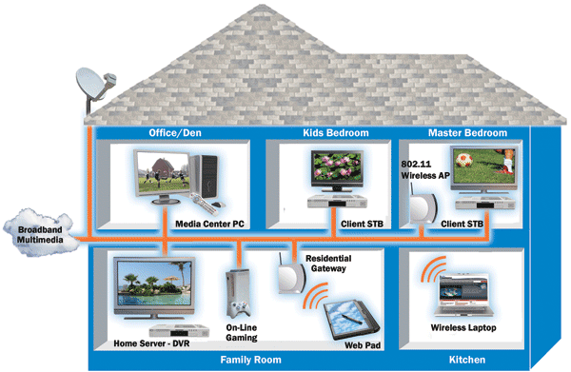

Structure of Networking between the different computers

**How networking works?**

**General Network Techniques** - When computers communicate on a network, they send out data packets without knowing if anyone is listening. Computers in a network all have a connection to the network and that is called to be connected to a network bus. What one computer sends out will reach all the other computers on the local network.

Computers on a network bus

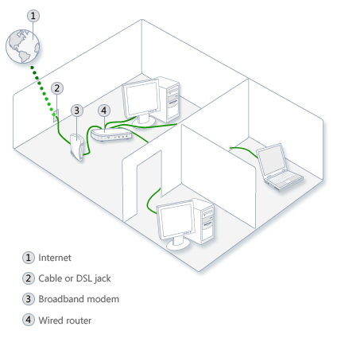

Above diagrams show the clear idea about the networking functions

For the different computers to be able to distinguish between each other, every computer has a unique ID called MAC-address (Media Access Control Address). This address is not only unique on your network but unique for all devices that can be hooked up to a network. The MAC-address is tied to the hardware and has nothing to do with IP-addresses. Since all computers on the network receives everything that is sent out from all other computers the MAC-addresses is primarily used by the computers to filter out incoming network traffic that is addressed to the individual computer.

When a computer communicates with another computer on the network, it sends out both the other computers MAC-address and the MAC-address of its own. In that way the receiving computer will not only recognize that this packet is for me but also, who sent this data packet so a return response can be sent to the sender.

**On an Ethernet network** as described here, all computers hear all network traffic since they are connected to the same bus. This network structure is called multi-drop.

One problem with this network structure is that when you have, let say ten (10) computers on a network and they communicate frequently and due to that they sends out there data packets randomly, collisions occur when two or more computers sends data at the same time. When that happens data gets corrupted and has to be resent. On a network that is heavy loaded even the resent packets collide with other packets and have to be resent again. In reality this soon becomes a bandwidth problem. If several computers communicate with each other at high speed they may not be able to utilize more than 25% of the total network bandwidth since the rest of the bandwidth is used for resending previously corrupted packets. The way to minimize this problem is to use network switches.

**Characteristics of Networking:**

The following characteristics should be considered in network design and ongoing maintenance:

1. **Availability** is typically measured in a percentage based on the number of minutes that exist in a year. Therefore, uptime would be the number of minutes the network is available divided by the number of minutes in a year.
2. **Cost**includes the cost of the network components, their installation, and their ongoing maintenance.
3. **Reliability**defines the reliability of the network components and the connectivity between them. Mean time between failures (MTBF) is commonly used to measure reliability.
4. **Security** includes the protection of the network components and the data they contain and/or the data transmitted between them.
5. **Speed**includes how fast data is transmitted between network end points (the data rate).
6. **Scalability**defines how well the network can adapt to new growth, including new users, applications, and network components.
7. **Topology**describes the physical cabling layout and the logical way data moves between components.

### Types of Networks:

Organizations of different structures, sizes, and budgets need different types of networks. Networks can be divided into one of two categories:

* peer-to-peer
* server-based networks

### Peer-to-Peer Network:

A peer-to-peer network has no dedicated servers; instead, a number of workstations are connected together for the purpose of sharing information or devices. Peer-to-peer networks are designed to satisfy the networking needs of home networks or of small companies that do not want to spend a lot of money on a dedicated server but still want to have the capability to share information or devices like in school, college, cyber cafe

### Server-Based Networks:

In server-based network data files that will be used by all of the users are stored on the one server. With a server-based network, the network server stores a list of users who may use network resources and usually holds the resources as well.  
This will help by giving you a central point to set up permissions on the data files, and it will give you a central point from which to back up all of the data in case data loss should occur.

**Network Communications:**

* Computer networks use signals to transmit data, and protocols are the languages computers use to communicate.
* Protocols provide a variety of communications services to the computers on the network.
* Local area networks connect computers using a shared, half-duplex, baseband medium, and wide area networks link distant networks.
* Enterprise networks often consist of clients and servers on horizontal segments connected by a common backbone, while peer-to-peer networks consist of a small number of computers on a single LAN.

**Advantages of Networking:**

1. **Easy Communication:**

It is very easy to communicate through a network. People can communicate efficiently using a network with a group of people. They can enjoy the benefit of emails, instant messaging, telephony, video conferencing, chat rooms, etc.

1. **Ability to Share Files, Data and Information:**

This is one of the major advantages of networking computers. People can find and share information and data because of networking. This is beneficial for large organizations to maintain their data in an organized manner and facilitate access for desired people.

1. **Sharing Hardware:**

Another important advantage of networking is the ability to share hardware. For an example, a printer can be shared among the users in a network so that there’s no need to have individual printers for each and every computer in the company. This will significantly reduce the cost of purchasing hardware.

1. **Sharing Software:**

Users can share software within the network easily. Networkable versions of software are available at considerable savings compared to individually licensed version of the same software. Therefore large companies can reduce the cost of buying software by networking their computers.

1. **Security:**

Sensitive files and programs on a network can be password protected. Then those files can only be accessed by the authorized users. This is another important advantage of networking when there are concerns about security issues. Also each and every user has their own set of privileges to prevent those accessing restricted files and programs.

1. **Speed:**

Sharing and transferring files within networks is very rapid, depending on the type of network. This will save time while maintaining the integrity of files.